Insert your name, centre number and candidate number into the header above.
Save this evidence document as evidence_ followed by your centre number_ candidate number. For example: evidence_ zz999_9999
Screenshots or program listings must be copied into appropriate cells in the following tables.
Examiners must be able to read the contents including any screenshots without the use of a magnifying glass. Answers that are not readable or missing will not be awarded any marks.
Save this evidence document at regular intervals, for example, every 10 minutes.
Question 1
Part 1(a)
{#DECLARE NumData:ARRAY[0:9]OF INTEGER
global NumData
NumData=[10,4,23,45,12,8,21,11,3,1]
}

Part 1(b)(i)
{def BubbleSort(Array):
global NumData
Flag=False
Boundary=9
while Flag==False:
Flag=True
for y in range(Boundary):
if NumData[y]>NumData[y+1]:
Temp=NumData[y]
NumData[y+1]=NumData[y]
NumData[y+1]=Temp
Boundary=Boundary-1
}

Part 1(b)(ii)
{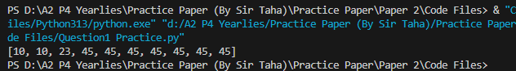 }

Part 1(c)(i)
{def BinarySearch(number):
#DECLARE upperbound, lowerbound, midpoint : INTEGER
#DECALRE valuefound, notinlist : BOOLEAN
global NumData
upperbound = 9
lowerbound = 0
valuefound = False
notinlist = False

while valuefound == False and notinlist == False:
midpoint = int((upperbound + lowerbound)/2)

if NumData[midpoint] == number:
valuefound = True
return True
elif NumData[midpoint] < number:
lowerbound = midpoint + 1
else:
upperbound = midpoint - 1

if lowerbound > upperbound:
notinlist = True
return False
}

Part 1(c)(ii)
{BubbleSort(NumData)
userinp=input("Enter a Number:")
Temp=BinarySearch(userinp)
if Temp==False:
print("Not Found")
else:
print("Found")
}

Part 1(c)(iii)
{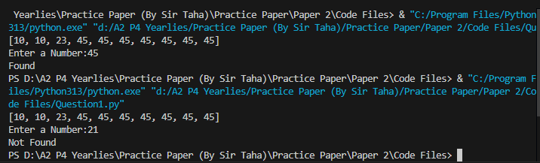 }

Question 2
Part 2(a)(i)
{class FoodItem():
#PRIVATE Name:STRING
#PRIVATE Code:STRING
#PRIVATE Cost:REAL
def __init__(self,Name,Code,Cost):
self.__Name=Name
self.__Code=Code
self.__Cost=Cost
}

Part 2(a)(ii)
{ def GetName(self):
return self.__Name
def GetCode(self):
return self.__Code
def GetCost(self):
return self.__Cost
}

Part 2(b)(i)
{class VendingMachine():
#PRIVATE Items:ARRAY[0:3] OF FoodItem
#PRIVATE MoneyIn:REAL
def __init__(self,Item1,Item2,Item3,Item4):
self.__Items=[]
self.__Items.append(Item1)
self.__Items.append(Item2)
self.__Items.append(Item3)
self.__Items.append(Item4)
self.__MoneyIn=0
}

Part 2(b)(ii)
{ def CheckValid(self,Code):
for x in range(len(self.__Items)):
if self.__Items[x]==Code:
if self.__MoneyIn<self.__Items[x].GetCode():
return -2
elif self.__MoneyIn>=self.__Items[x].GetCode():
return x
else:
return -1
}
Part 2(b)(iii)
{ def GetItemName(self,index):
Temp=(self.__Items[index].GetName())
return Temp
}
Part 2(b)(iv)
{chocolate = FoodItem("Oreo", 54, 5.4)
sweets = FoodItem("Custard", 12, 2.1)
sandwich = FoodItem("Peri Peri", 67, 10.1)
apple = FoodItem("green", 3, 1.3)
machineOne = VendingMachine(chocolate, sweets, sandwich, apple)
print(machineOne.GetItemName(2))}

Part 2(b)(v)
{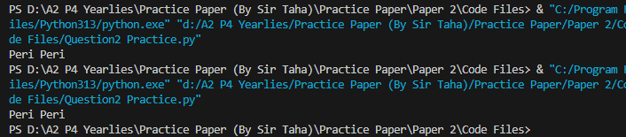 }

Question 3
Part 3(a)
{class node:
# PUBLIC Data : INTEGER
# PUBLIC nextNode : INTEGER
def __init__(self, DataP, nextNodeP):
self.Data = DataP
self.nextNode = nextNodeP
}

Part 3(b)
{# DECLARE startPointer, emptyList : INTEGER
# DECLARE LinkedList : ARRAY [0:9] OF node
LinkedList = [node(1,1), node(5,4), node(12,7), node(41,-1), node(8,2), node(0,6), node(0,8), node(32,3), node(0,9), node(0,-1) ]

startPointer = 0
emptyList = 5
}

Part 3(c)(i)
{def outputNode(array, currentpointer):
while currentpointer != -1:
print(array[currentpointer].Data)
currentpointer = array[currentpointer].nextNode
}

Part 3(c)(ii)
{def Addnode(datatoinsert, currentpointer):
global LinkedList
global emptyList
global startPointer

if emptyList < 0 or emptyList > 9:
return False
else:
freelist = emptyList
emptyList = LinkedList[emptyList].nextNode

newNode = node(datatoinsert, -1)

LinkedList[freelist] = newNode

while currentpointer != -1 and LinkedList[currentpointer].Data < datatoinsert:
previouspointer = currentpointer
currentpointer = LinkedList[currentpointer].nextNode

if currentpointer == startPointer:
LinkedList[freelist].nextNode = startPointer
startPointer = freelist
else:
LinkedList[freelist].nextNode = LinkedList[previouspointer].nextNode
LinkedList[previouspointer].nextNode =freelist

return True
}

Part 3(d)(i)
{outputNode(LinkedList, startPointer)
temp = Addnode(67, startPointer)
outputNode(LinkedList, startPointer)
}

Part 3(d)(ii)
{if temp == True:
print("Value Added")
else:
print("Not Added")
}

Part 3(d)(iii)
{ 

